Phase 2 Assessment Learner’s Academy

Learner’s Academy is a school that has an online management system. The system keeps track of its classes, subjects, students, and teachers. It has a back-office application with a single administrator login. The Project is divided into 4 Sprints each of one week.

**1st Sprint:-**

* Created Admin Login Form with single [UserId=LearnerAcademy@gmail.com](mailto:UserId=LearnerAcademy@gmail.com) and Password=1234
* Created backend Servlet which handles the login Credentials

**2nd Sprint:-**

* Created Dash-Board page which holds the address for inserting the details of Students,Teachers &Classes
* Created Student form HTML
* This student form accepts the details provided by the admin
* Created AddStudent servlet which inserts the details provided by the admin into Database
* Created DeleteStudent servlet which deletes the record from database which is specified by the admin

**3rd Sprint:-**

* Created Teacher form HTML
* This teacher form accepts the data provided by the admin
* Created AddTeacher servlet which inserts the provided by the admin into Database
* Created DeleteTeacher servlet which deletes the record from database which is specified by the admin

**4th Sprint:-**

* Created View.html for displaying the details from database
* Created ReadStudent servlet which displayes the student details
* Created ReadTeacher servlet which displayes the Teacherdetails
* Created ReadClass servlet which displayes the details of class
* Added Logout.html for logout operation
* Added Logout servlet for invalidating the Session

**Methods and operations:-**

We have 6 operations that user can perform.

* Admin Login
* Insert records of Teachers , Students & Classes.
* Delete Records of Teachers .
* Display List of Students,Teachers &Classes.
* Delete Details of Students .
* Admin Logout

Core concepts

The Whole Application is based on Hibernate, Html,Java,Servlets ,MySql BENCH database.For Login/Logout I have used a simple HTML and Servlet that handles the operation of Login/Logout.

I have created the MYSQL connection through hibernate.cnfg.xml file which establishes the connection between database and the eclipse editor.

I have created Servlets for operations like Inserting data into the database & retrieving data from database and also displaying with the corresponding ReadServlet ,AddServlet.

I have created a DashBoard Page which holds the address of adding displaying the details of Teachers,Students & Classes.

I created View Html file which displayes the details of Class,Students,Teachers with the help of ReadServlet which retrieves the details from database

At Last I created Logout Html for Logout Operation and also a Servlet which Handles the operation of Logout

**Refer The following Code Snippets:-**

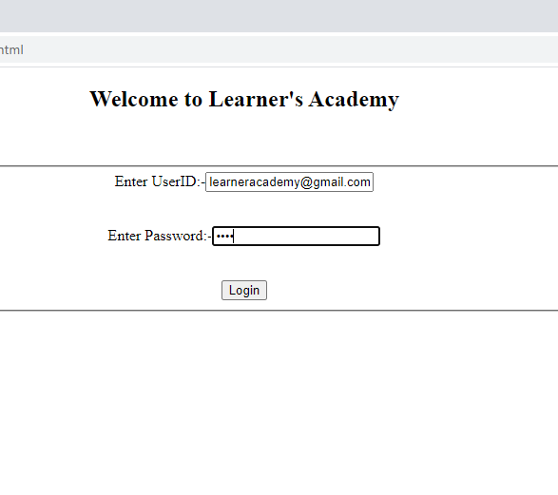

Fig(1)Login Form

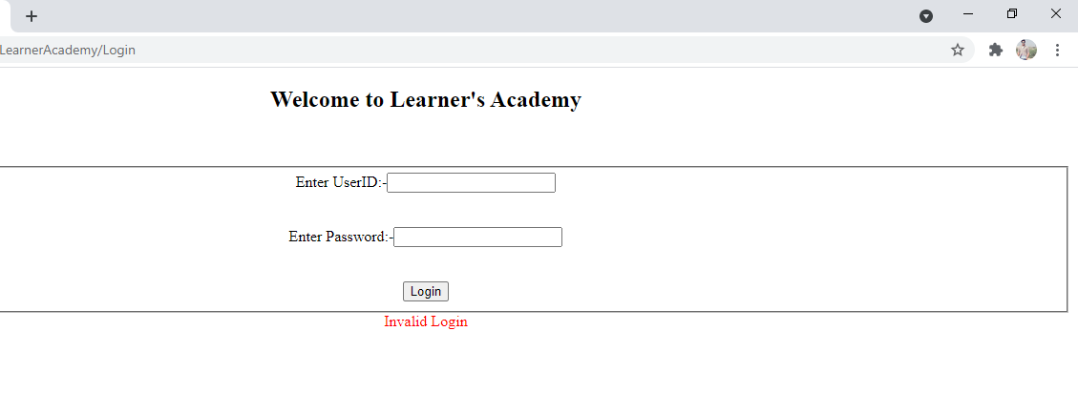

Fig(2) If User Doesn’t provide the credentials it displays Invalid Login

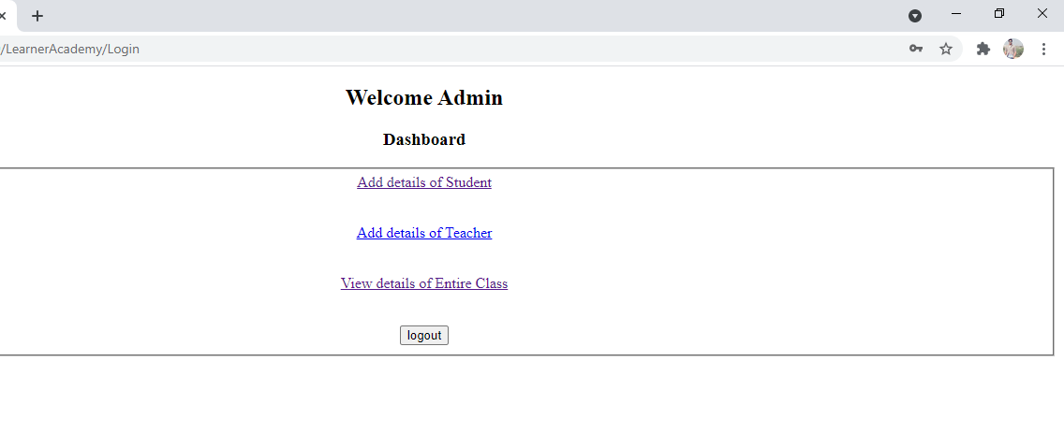

Fig(3) If Admin Logs In he will redirected towards Dashboard page as shown in above Picture

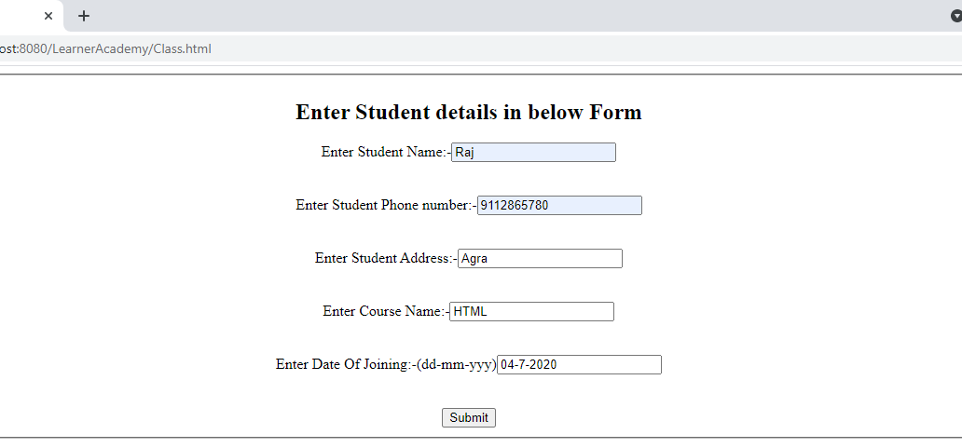

Fig(4) If Admin clicks on Add details of Student the above form will be displayed

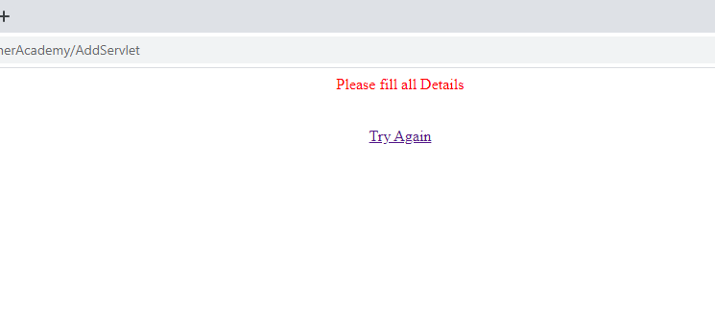

Fig(5) If Admin Doesn’t provide details the error will be displayed as shown in above picture

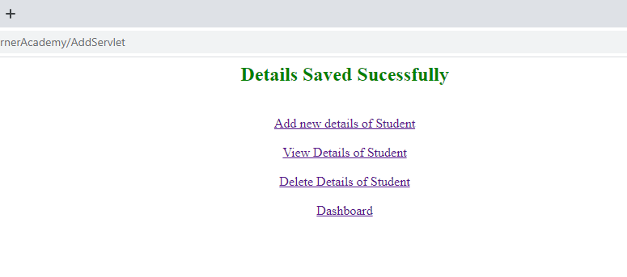

Fig(6)If Admin Enters details and submits then the above picture is displayed

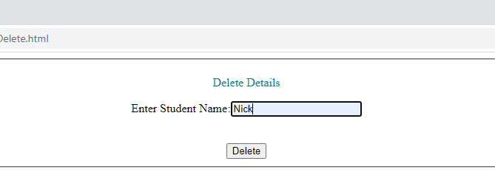

Fig(7)If admin Wants to delete any record which is shown in above picture

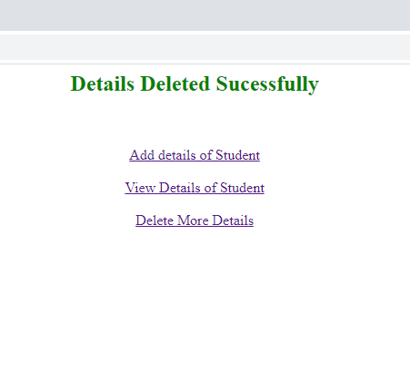

Fig(8)After deleteing the record the above page will be displayed

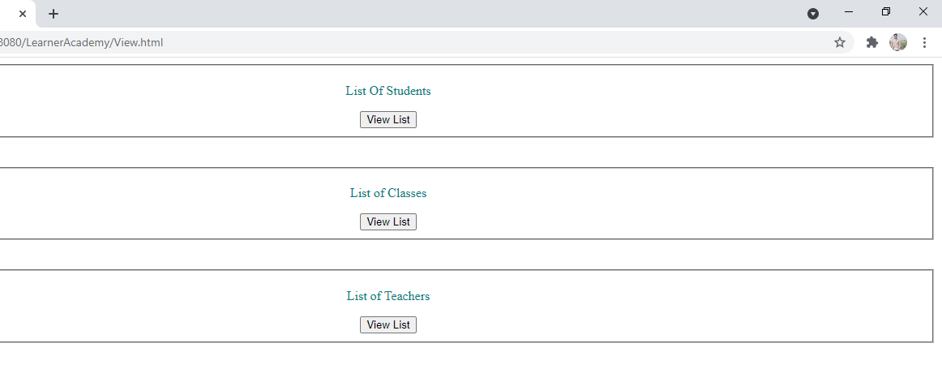

Fig(9)If Admin Click view button from dashboard page the above picture will be displayed

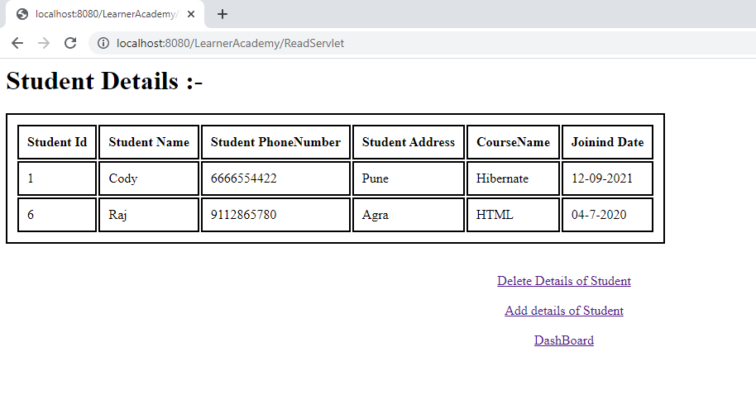

Fig(10)The student details will be displayed as shown in above picture

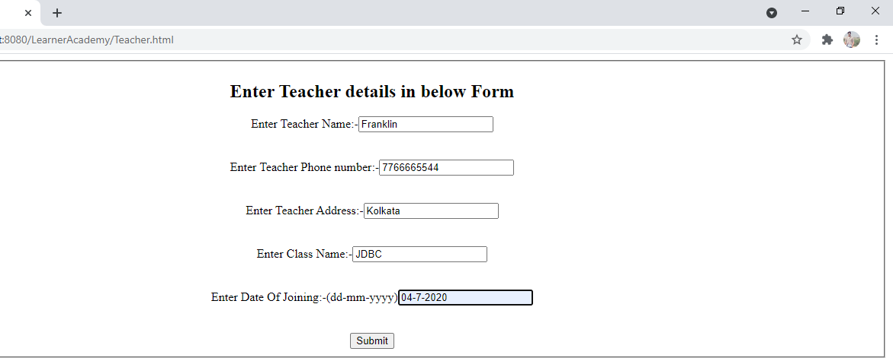

Fig(11)Teacher Form as shown in above picture

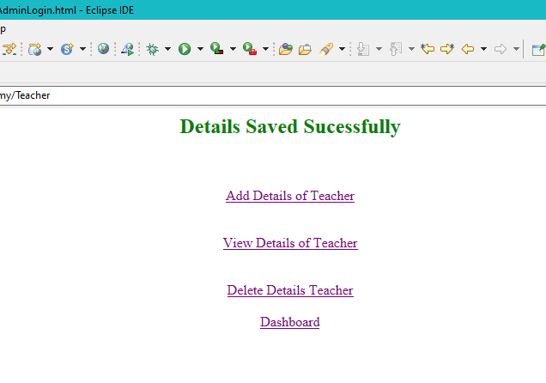

Fig(12)After Submittng details the above page is displayed

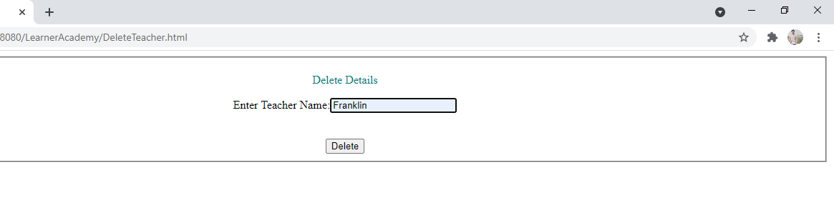

Fig(13)Teacher details Delete form as shown in above picture

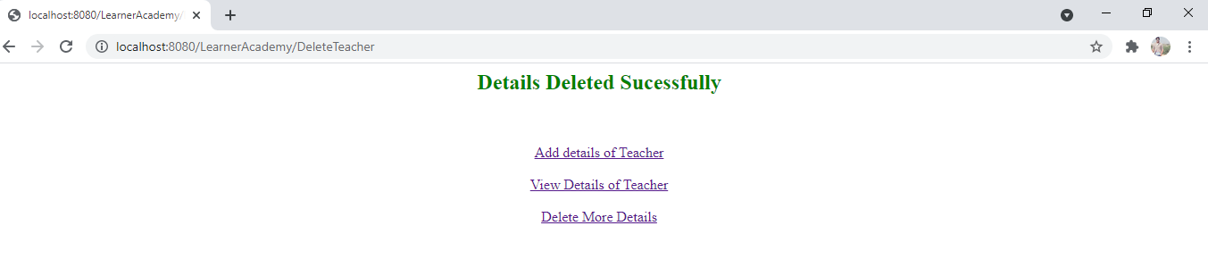

Fig(14)The above page is displayed after deleting the details

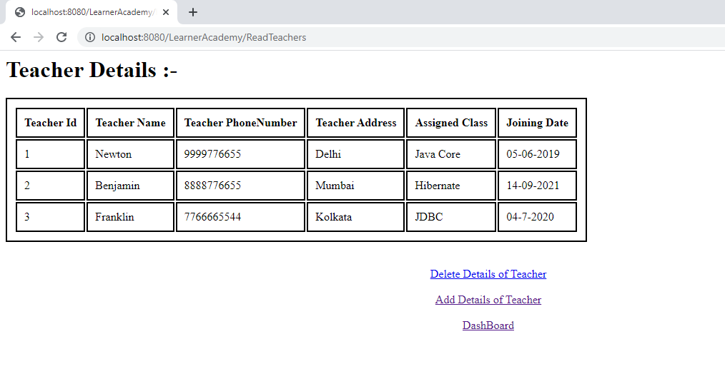

Fig(15)Teacher details displayed as shown in above picture

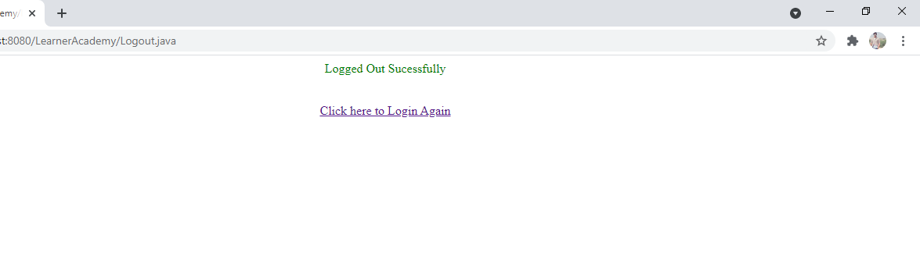

Fig(16) When Admin clicks on logout button the above page will be displayed